Name
Institution
Course
Professor
Date

SURVIVAL ANALYSIS USING COX PROPOTIONAL HAZARDS REGRESSION
Machine learning is commonly used at the beginning level stage in research involving large datasets from biomedical facilities. For instance, to assist in identifying candidate genes or diseases that can be predicted through the help of biostatisticians. More so data obtained from clinical trial majorly entails survival data that requires to be approached in a different way for analysis.
When conducting analysis of such nature, the period to an event or the time, example death or disease occurrence is of great interest. Two or more groups of individuals are thus compared based on the time that particular event is likely to happen (Williams et.al, 2017). Based on the information above thus, we can define survival analysis as a statistics division which analyzes the anticipated amount of time when a single or more event happens for instance death. Survival analysis assist in giving solutions to problems like the proportion of a given population that is likely to survive previous or a certain time. In the event that there is a chance of survival, then what is the rate that death or the later will occur. Generally, analysis of this nature in cooperates the exhibiting of event data. In the setting above demise or failure to die is taken to be an incident in the literature involving survival analysis. Different models are used in Survival analysis in order to arrive to the intended results, one of the commonly known methods that we are going to consider in this context during our analysis is the cox proportional hazards model.
The proportional model involves a useful function denoted by h(t). This refers to the likelihood of an event or the hazards h (in this case is survival) and the point of time t a subject survived. This method measures the risk of death instantaneously and it is difficult to illustrate as compared to the Kaplan-Meier estimator. However, this method is necessary when comparing covariates and survival group of patients. Covariates also known as independent or explanatory variables are normally predictive to an outcome. Cox proportional hazards models only assumes that the hazards of the group of patients compared are constant over time and does not assume the primary probability distribution (Austin, 2017). It is important to note that provided that the assumption of this regression model is met, then good estimates of probabilities based on survival and cumulative hazards are obtained. Survival analysis will be the major concern in this particular assignment. This is because we have incomplete data which commonly referred to as censoring in the data set that we are going to use. Also, we are majorly concerned in the risk of dying which is not related to patient treatment group, which forms our hypothesis.

Data analysis
The data used is divided into four groups where we have time that represents survival trial of a subject, status at trial time(1=event,0=censored), subject and treatment group(1 chemo or 2placebo). It is important to prepare the data to prepare the data in a workbook column in excel for proper analysis. The analysis will involve RStudio software where the data set survival curve will be imported to R before beginning the analysis.

Summary Statistics

Group Time Status
Min. :0.500 Min. :0.0000 Min. :1.0
1st Qu.:1.000 1st Qu.:1.0000 1st Qu.:1.0
Median :2.000 Median :1.0000 Median :1.5
Mean :2.396 Mean :0.8333 Mean :1.5
3rd Qu.:3.625 3rd Qu.:1.0000 3rd Qu.:2.0
Max. :5.000 Max. :1.0000 Max. :2.0

Cox proportional hazards Regression Model with group as predictor

n= 12, number of events= 10

coef exp(coef) se(coef) z Pr(>|z|)
Group 1.2306 3.4232 0.7485 1.644 0.1

exp(coef) exp(-coef) lower .95 upper .95
Group 3.423 0.2921 0.7894 14.84

Concordance= 0.667 (se = 0.067 )
Likelihood ratio test= 2.81 on 1 df, p=0.09
Wald test = 2.7 on 1 df, p=0.1
Score (logrank) test = 3.01 on 1 df, p=0.08

Comparing survival time between Groups
N Observed Expected (O-E)^2/E (O-E)^2/V
Group=1 6 5 7.22 0.685 3.07
Group=2 6 5 2.78 1.782 3.07
Chisq= 3.1 on 1 degrees of freedom, p= 0.08

We use the surv function in R to get the following output, here we test whether the difference in the survival period based on the treatment group in the survival curve data.

Proportionality Test
Chisq df p
Group(1 chemo or 2placebo) 0.0138 1 0.91
GLOBAL 0.0138 1 0.91

The survival chart
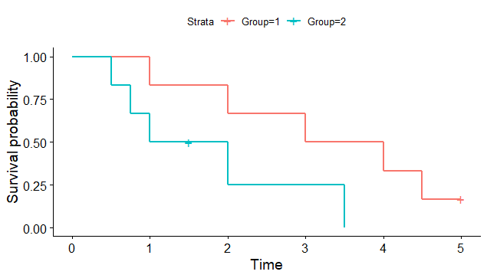

Interpretation
The log rank shows that the p-value is 0.08. This suggest that there no change among the patient treatment groups that is (1 chemo and 2 placebo) in their relationship to survival.
Hypothesis
H0 (null hypothesis): the risk of dying is not related to patient treatment group
Vs
Ha (alternative hypothesis) : the risk of dying is related to patient treatment group.
The following interpretation can thus be made based on the hypotheses above:
It is observed that the p-value is 0.08 which is greater than 0.05 at the alpha level of significance. In such a case the null hypothesis is rejected. Therefore, based on our research question we can conclude that the risk of dying is not related to the treatment group where a patient is placed. The graph above shows the survival probability for a period of time based on the treatment group. The blue color indicates the first treatment group which is chemo while the red color mark indicates the second treatment group which is placebo. At year 2 it is observed that the survival probability for patient in group 1 is 0.25 while for group 2 it is 0.75 further giving more evidence to further not accept the alternative hypothesis. This model further investigates the effect of these two treatment groups on patients (Moitahedi et.al, 2017). In the survival analysis model, proportionality is normally indication of whether the subjects under study survived or died. In addition, based on the assumption made when developing this model the proportion of the hazards is similar in the treatment groups.

Conclusion
This model is a best model when compared to Kaplan-Meier estimator based on our findings. It is thus a model that can be used in biomedical and research institutions where clinical research trials are involved. This is because it has reported clearly the hazards ratios and the proportionality between the two groups under study (Austin et.al, 2017). Thus, we were able to fail to reject the null hypothesis and conclude that the risk of death is not related in any way to the treatment group a patient is placed.

References
Williams, C., Lewsey, J. D., Briggs, A. H., & Mackay, D. F. (2017). Cost-effectiveness analysis in R using a multi-state modeling survival analysis framework: a tutorial. Medical Decision Making, 37(4), 340-352.
Austin, P. C. (2017). A tutorial on multilevel survival analysis: methods, models and applications. International Statistical Review, 85(2), 185-203.
Mojtahedi, M., Newton, S., & Von Meding, J. (2017). Predicting the resilience of transport infrastructure to a natural disaster using Cox’s proportional hazards regression model. Natural Hazards, 85(2), 1119-1133.
Austin, P. C., Pencinca, M. J., & Steyerberg, E. W. (2017). Predictive accuracy of novel risk factors and markers: a simulation study of the sensitivity of different performance measures for the Cox proportional hazards regression model. Statistical methods in medical research, 26(3), 1053-1077.

